Uxbridge Bikeway 2019 Photos
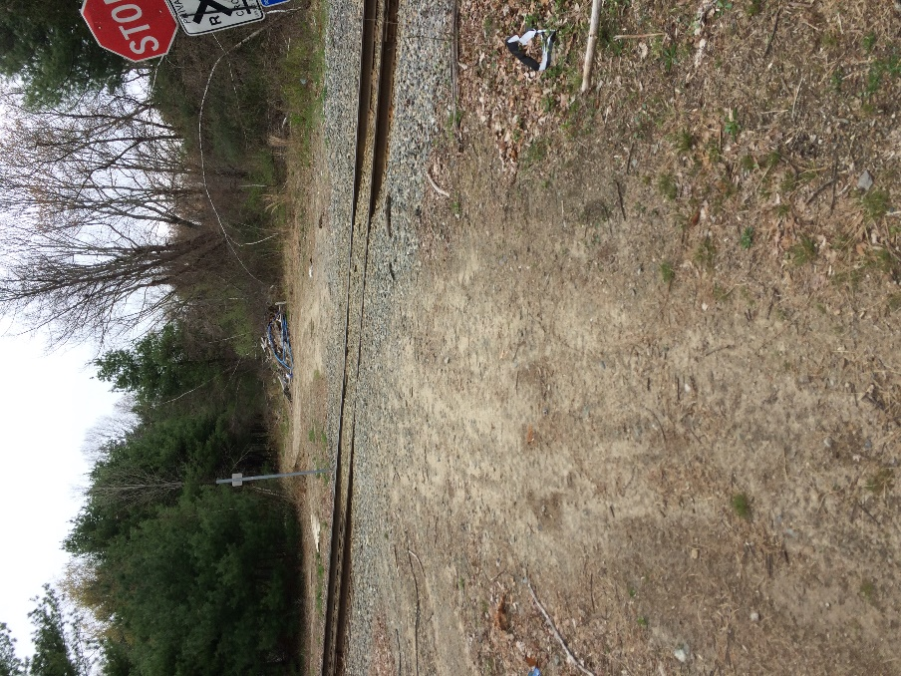
Details of Railroad Crossing
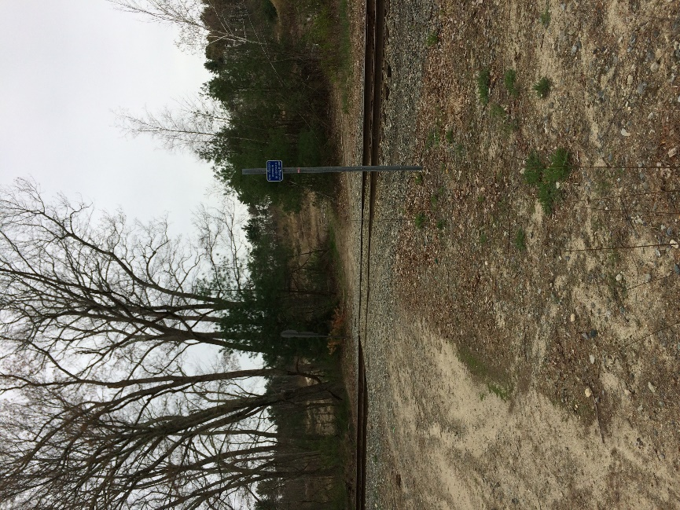
Railroad Crossing Looking West

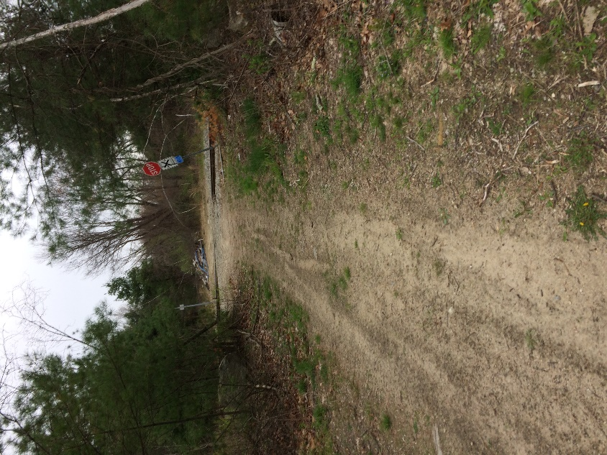
Railroad Crossing Looking East

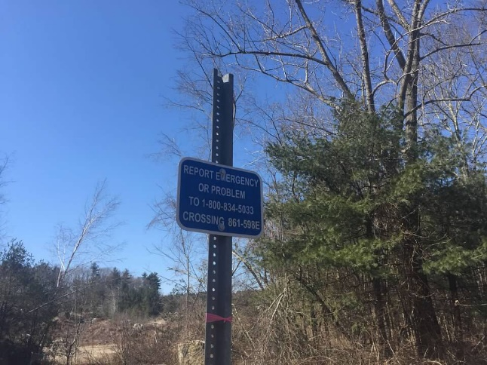
Crossing Sign
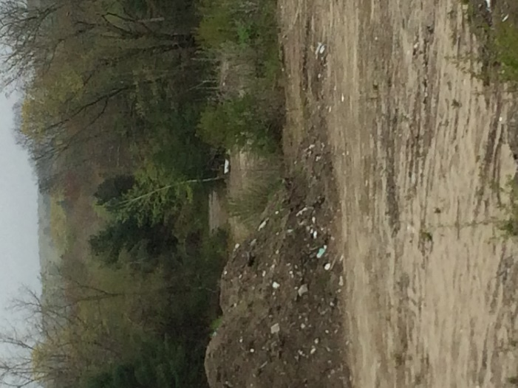
Crossing at Distance Looking East from Route 122/ Post Office
(Prior to construction on Property)

